# **Name: Abdurrahman Qureshi**

# **Roll No: 210451**

Practical No: 28

**1) Develop a basic applet to display ‘Welcome to the World of Applet’**

**CODE:**

import java.awt.*;  
import java.applet.*;  
/*  
<html>  
 <body>  
 <applet code="Main.class" width="200" height="200"></applet>  
 </body>  
</html>  
*/  
public class Main extends Applet {  
 public void paint(Graphics g) {  
 g.drawString("Welcome to the World of Applet", 20, 20); }}

**OUTPUT:** 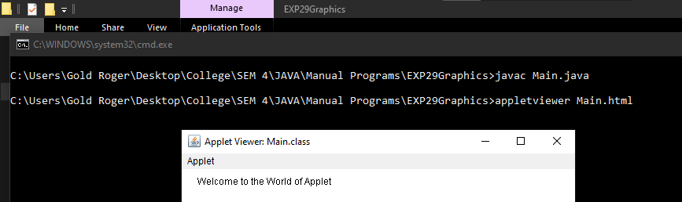

**2) Converting string to integer**

**CODE:**

import java.awt.*;

import java.applet.*;

/*

<html>

<body>

<applet code="Main.class" width="200" height="200">

</applet>

</body>

</html>

*/

public class Main extends Applet {

public void paint(Graphics g) {

setBackground(Color.RED);

setForeground(Color.WHITE);

g.drawString("Hello Spectre!!!", 20, 20); }}

**OUTPUT:**

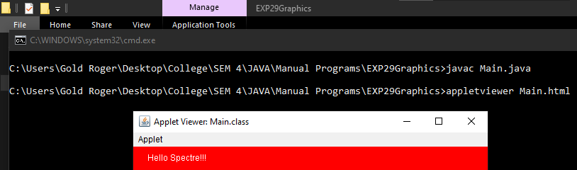

**3) WAP to draw a bar chart for plotting students passing percentage in last 5 years.**

**CODE:**

import java.applet.*;

import java.awt.*;

public class Main extends Applet {

int[] percentage = {75, 80, 85, 90, 95};

String[] years = {"2017", "2018", "2019", "2020", "2021"};

Color[] colors = {Color.red, Color.green, Color.blue, Color.yellow, Color.orange};

public void paint(Graphics g) {

g.setFont(new Font("Arial", Font.PLAIN, 12));

int maxPercentage = 95;

int width = 800;

int height = 300;

int barWidth = width / percentage.length;

g.setColor(Color.black);

g.drawString("Passing Percentage in Last 5 Years", 50, 20);

for (int i = 0; i < percentage.length; i++) {

g.setColor(colors[i]);

int barHeight = (int)((double)percentage[i] / maxPercentage * (height - 50));

g.fillRect(i * barWidth + 50, height - barHeight - 30, barWidth - 20, barHeight);

g.setColor(Color.black);

g.drawString(years[i], i * barWidth + 50, height - 10);

g.drawString(Integer.toString(percentage[i]) + "%", i * barWidth + 50, height - barHeight - 35);

}

}

}

**OUTPUT:**

